**Sampling Instructions**

**Kit Contents**

Check the contents of your kit. You should have 50 ml. labeled sample tube with sample number , a refrigerator magnet with a matching sample number, a piece of Parafilm™, a small plastic bag, a cover letter, datasheet, and instructions for sampling along with a postage paid return envelope. Let us know if you are missing anything!

## **The Sample Process**

* Fill out the paper datasheet supplied with your sample kit and sign to give your permission for us to analyze your water sample. Samples will not be analyzed without this signature.
* Register your water sample on the Arsenic and Aging project on our citizen science data portal, at [https://www.anecdata.org/projects/view/arsenic-and-aging](https://nam02.safelinks.protection.outlook.com/?url=https%3A%2F%2Fwww.anecdata.org%2Fprojects%2Fview%2Farsenic-and-aging&data=05%7C01%7Cjdisney%40mdibl.org%7C3e639b8bc2ce4581f83708dadc8a3a37%7C2dd2ec8b30534918ac5886eed5446f48%7C1%7C0%7C638064783491450573%7CUnknown%7CTWFpbGZsb3d8eyJWIjoiMC4wLjAwMDAiLCJQIjoiV2luMzIiLCJBTiI6Ik1haWwiLCJXVCI6Mn0%3D%7C3000%7C%7C%7C&sdata=5IYvhjepzkOgnGuSndwCcSsTbyarTnGfZ43EufXYT38%3D&reserved=0).

Here is how to do it. Go to the URL above. Click on “ + New Observation”. See the red arrow below! Enter the information you recorded on your datasheet into the online form. Hit Save!

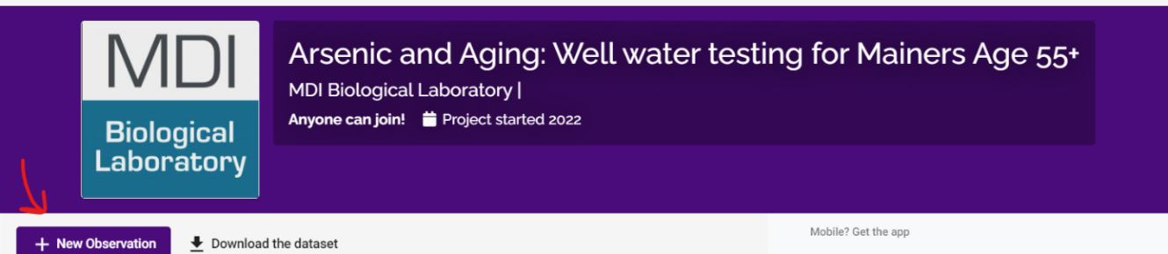

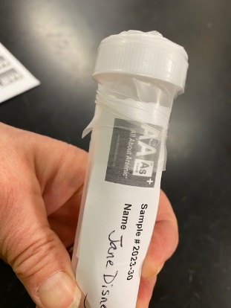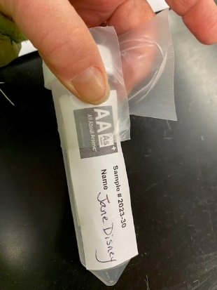

**If you have trouble registering your sample, indicate that on your datasheet and we will do it for you.**

* If you have well water, run your kitchen faucet for 5 minutes. If you are on public water, sample first thing in the morning before using your kitchen faucet. Do not bypass a kitchen sink filtration system.
* Collect 45 ml. of water sample into the vial and cap. Dry the tube off, if necessary, without damaging the label. Remove the paper from the Parafilm™ sealing film and seal the tube with it. Do this by stretching the parafilm around the cap and sealing it to itself. It sticks!

Wrap the sealing film around the cap where it meets the tube. It will self-seal.

* Place the sealed tube into the small plastic bag supplied with your sample kit and seal.
* Return your sample in the postage paid envelope with your signed datasheet folded in eighths. That is the only sheet you need to return. There is no hurry, the samples are stable until you are ready to mail them.
* Put your refrigerator magnet somewhere that you can find it later. You will want your sample number to look up your results when they are available. You can visit the [AllAboutArsenic.org](https://www.allaboutarsenic.org/legacy-scholars/) website, enter the Arsenic and Aging Project Portal, then type your sample number into the “For Samplers” look-up tool to find your well water test results. You will find other helpful information at the website as well.

**Any questions? Contact Jane Disney at jdisney@mdibl.org**